AUTHORIZATION FORM FOR MINORS TO PARTICIPATE

I, the undersigned ……………………………………………………………………………………………..
born in .................…………………………………………. on …………………………....…………....................
resident .......................……………......………………………………………………………………………………,
telephone ……………………………………. e-mail ………………………………………………………..

As the parent exercising parental authority of:

…………………………………………………………………………………… of years ………………………

By signing this document you declare that you:

to have read the regulations of the "ITALIAN AWARD FOR PALEOART"

- and accept all the terms and conditions indicated therein;
- consent to the participation of my child in the "ITALIAN AWARD FOR PALEOART".

Place and Date Parent Signature
………………………… ………………………………………

IN THE CASE OF VIDEOS OR PICTURES OF MY OWN SON/DAUGHTER

I also grant permission for the use of the images of my son/daughter
………………………………………………………………… of years ………………………………………..

within the communication channels of the Paleontological Museum of Montevarchi, in contexts that do not affect its personal dignity.

Place and Date Parent Signature
………………………… ………………………………………

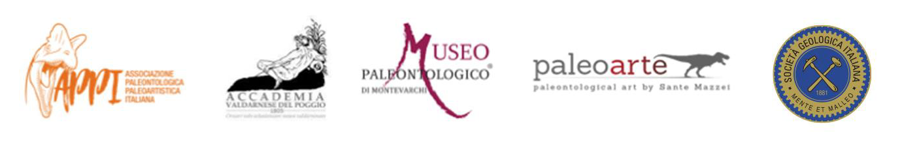
Information provided pursuant to Articles 13-14 of GDPR 2016/679 (General Data Protection Regulation).

